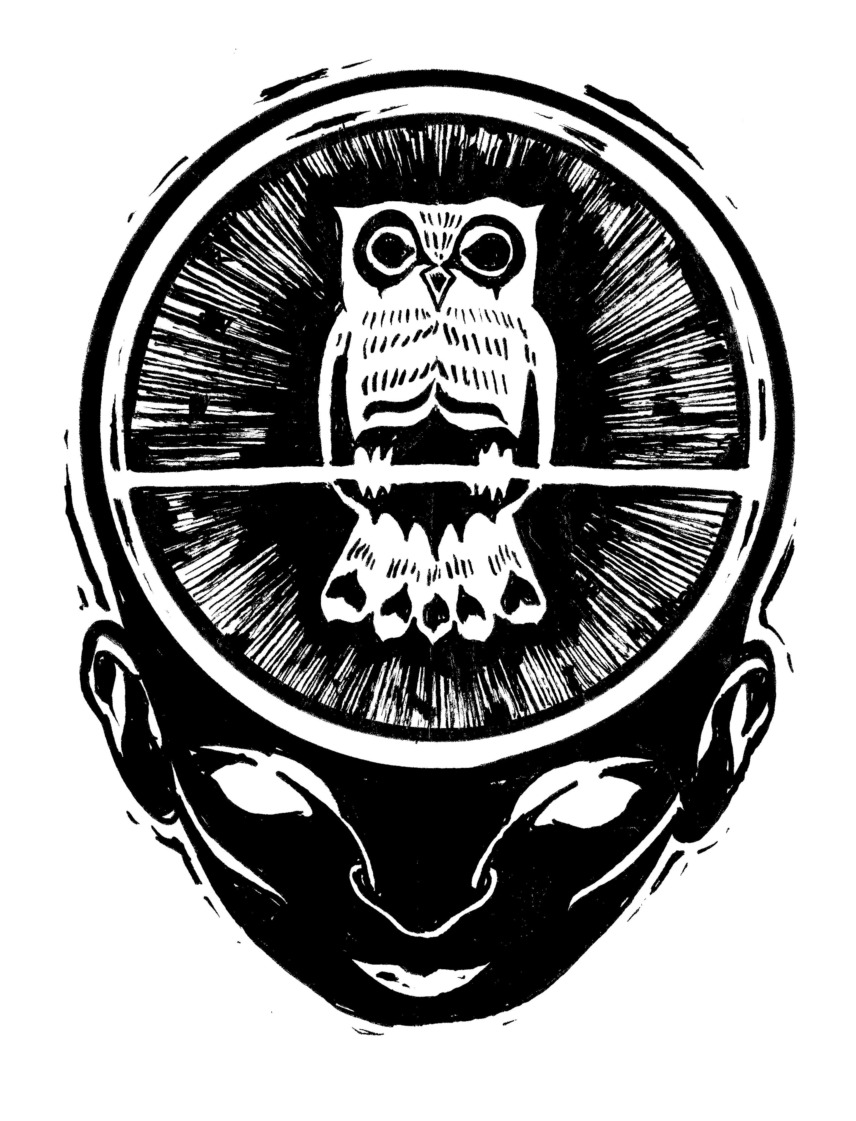
Wild Intelligence, LLC
Adult Medical and Release form

PLEASE NOTE: Because of the ever-changing nature of medical and other requested information, we require that a new form be completed for each program you attend.

Program Name: Introduction to Coyote June 21, 2014 at Orange Twin Conservation Land

Date: _______________
Participant's Name: _____________________________________________________________________
Male ____ Female_____ Date of Birth __________________ Age ____________________________
Street Address: _________________________________________________________________________
City: _____________________________________State: ______ _________Zip: ____________________

Phone: (H)_________________ (W) _________________Cell _________________E-mail ____________
EMERGENCY CONTACT INFORMATION:
Name: _________________________________________ Relationship: __________________________
Home Phone: _______________Work/Other Phone: ________________E-Mail __________________
INSURANCE INFORMATION (if you do not carry health insurance, please indicate so):
Name of Health Insurance Carrier: _______________________________________________________
Group/Plan Number: __________________________________ Phone: __________________________
Personal/Family Physician: ______________________________ Phone: ________________________
Date of last tetanus booster: _________________
MEDICAL CONDITIONS:
If you have any personal medical condition or problem that Wild Intelligence should be aware of, it is your responsibility to acquaint us with the existing condition both in this form as well as at registration for the program. The information will be held in confidence and used only to render proper assistance should the need arise.
1. Do you wear: contact lenses/glasses? ________ , or hearing aid? _______
2. Do you have asthma? __________ . If so, do you have medication? (specify):______________
3. Do you have (or have you ever had) a heart condition? __________ . If so, please describe your limitations, medication (if any) and history:

4. Do you have any physical disabilities, injuries or limitations that could become a problem or become aggravated during this program? If so, please describe the disability/injury/limitation and its history:

5. Are you currently on any medication? _______. If so, indicate the specific medication, condition prescribed for and any known negative drug interactions:

6. Is there any other condition that we should be aware of that may endanger, alter, or somehow limit your abilities to participate in our programs? Please describe in detail:

7. Have you ever been stung by a yellow jacket, wasp or bee? (Yes/No)_________________________________
If YES, please specify 1) what stung you and 2) if there was any allergic reaction:

8. Are you allergic to any of the following? If so, please give specific reaction to each, degree of sensitivity (10 being deathly allergic and 1 being mildly) and specific allergen:
1.) Medication (i.e. penicillin, aspirin):
2.) Insect bites (i.e. wasps, bees):
3.) Foods (i.e. peanuts, chocolate):
4.) Plants:
5.) Other:
Do you use medication for allergic reactions (i.e. EpiPen, Benadryl)? If so, what do you use?
Note: (We do require that if you do have known anaphylactic allergic reactions that you bring medication to counter it appropriately - i.e. EpiPen or AnaKit).

9. If the program you are registered for includes meals, are you Vegetarian? ______ Vegan? ___ Other special food needs ______________________________________________________________.

PHOTO/VIDEO RELEASE: By signing below I hereby grant free permission for Wild Intelligence, INC to use still or motion picture images of myself participating in their programs or events for outreach purposes, including but not limited to electronic or print materials, or print or broadcast media. [__] No, I do not wish to grant a photo release. (please consider granting this release to us if at all possible, as our ability to successfully share our programs with new participants depends on having representative photographs and video.)

RELEASE, INDEMNIFICATION AND WAIVER FORM: (This is a release – please read it carefully.)
I, the undersigned, hereby acknowledge that I have been advised and fully understand that certain elements of danger are inherent in the activities sponsored by Wild Intelligence, INC which are beyond the control of the instructors, agents, officers, students, and employees of Wild Intelligence, INC, and that participation in any program activities may entail unavoidable risk of personal injury, death, and loss of or damage to property. These risks include, but are not limited to insect and animal bites and stings (including but not limited to ticks, yellow jackets, wasps, venomous snakes), forces of nature such as but not limited to lightning, and unexpected extreme weather conditions, and any hazard present in the wilderness, such as but not limited to low lying branches, falling trees or tree limbs, contact-irritant plants (i.e. poison ivy), sharp objects, and slippery surfaces.

I hereby assume all risks of injury and death to myself and loss of or damage to property arising out of my participation in such activity and I agree to indemnify, hold harmless Wild Intelligence, INC, its officers, instructors, agents, and employees (“Releasees”) from and against all claims arising from any occurrence causing damage or injury to myself or to any party participating in said event or any third parties injured as a result of my actions. I further agree to repair or reimburse Wild Intelligence INC for any and all damages that I cause to Wild Intelligence, INC property or the property at which a specific activity is held.

Prior to signing below, I have read and understand the terms and conditions of this Release, Indemnification, and Waiver, understand by signing below I am waiving certain legal rights I may have against the Releasees, and I agree to subscribe to all the terms and conditions set out above.

Participant's Signature: _____________________________________ Dated: ___________
Printed Name: _____________________________________________________________________

Please return form to Wild Intelligence, INC
PO Box 1441
Athens, GA 30603

